Online Textbook Instructions
- Go to your NC EDCLOUD homepage
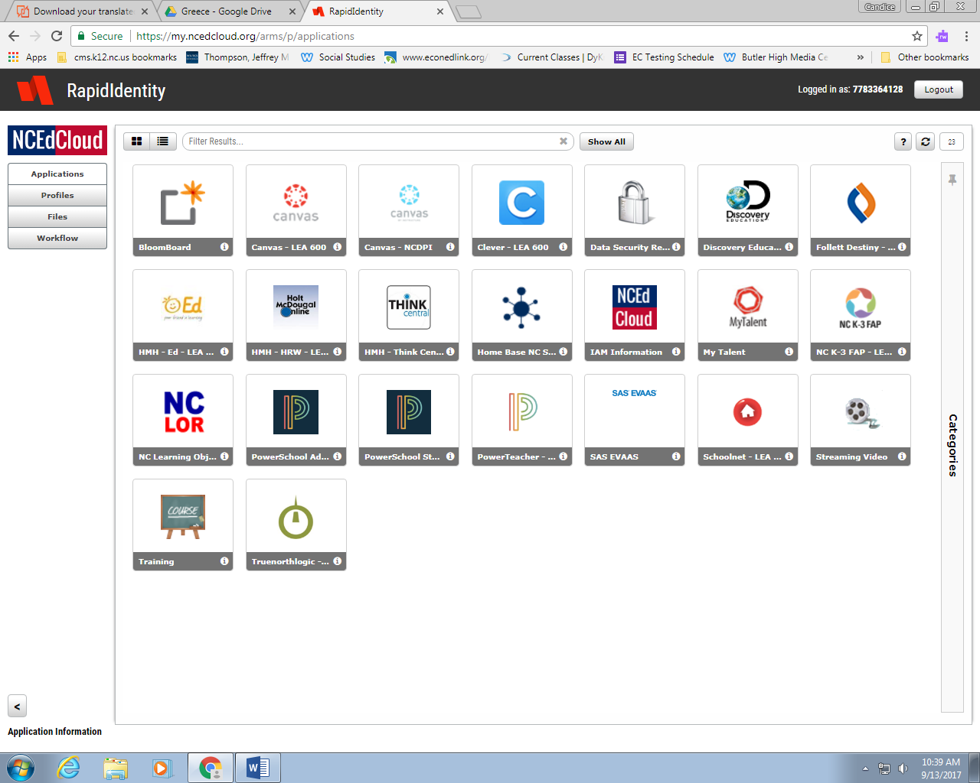

- Choose the HMH-Ed button
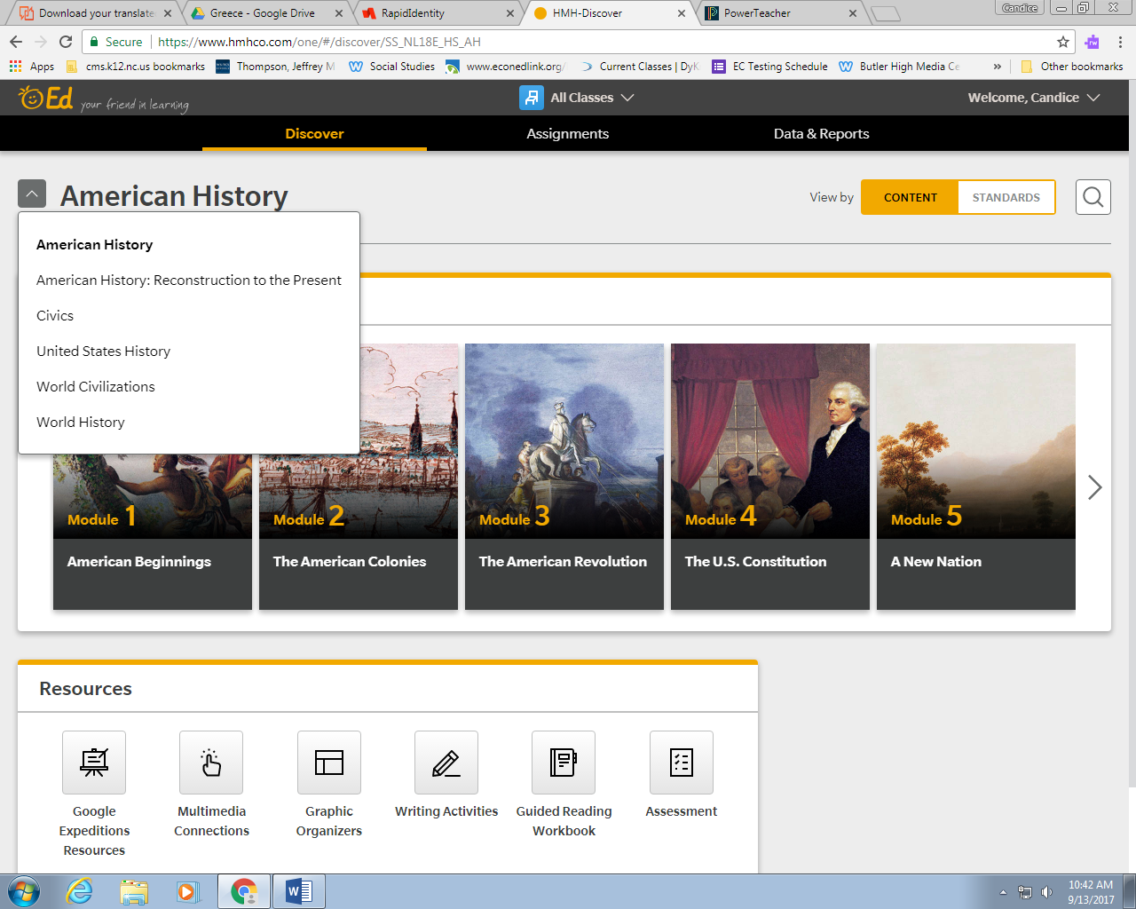
- Select your course:
World History or
American History

